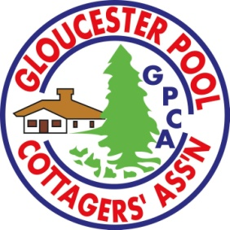 GPCA – ART ON THE DOCK 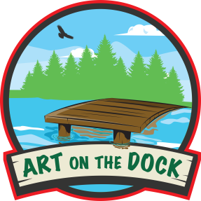
July 13, 2024
10:00 to 3:00 p.m.
ARTIST/ARTISAN’S APPLICATION
Entry Fee $50
Name: ______________________________________________________________
Cottage Address: _____________________________________________________
____________________________________________________________________
Email: ______________________________________________________________
Website: ____________________________________________________________
Facebook: ___________________________________________________________
Instagram: __________________________________________________________
Telephone Numbers: Home ___________________ Cell ______________________
Items for sale/ Medium: ______________ _________________________________

PLEASE INDICATE:
 I have my own dock for the tour
 I can host a guest artist/artisan (we will consult with you on the best fit for your space)
 I need to be placed at a public location - GPCA Clubhouse
 I am a guest artist and request to be with _____________________________________

Biography: max 75 words to describe you and your work
_______________________________________________________________
_________________________________________________________________
_________________________________________________________________
__________________________________________________________________
__________________________________________________________________
Please email five High Resolution photos of your work for the jury and use in advertising/marketing to Kathleenrodgers60@gmail.com.

Guidelines:
1. All items for sale are to be handmade by yourself, and/or with help from your family. Please be careful of copyright.
2. Good docking facilities at your cottage are very important. It is your responsibility to ensure your dock is in good condition and free of any obstacles. Identify any hazards nearby in the water with a buoy marker. You will need extra people to help with boater docking. Most people come by boat.
3. Please check your insurance coverage for the day event in case of an accident, like a slip or fall or some dock or boat damage.
4. This event is open to members of the GPCA. Who is the primary member in your family?
__________________________________________________________
5. Guest Artists are welcome.
5. Payment options for your customers – cash, credit card /debit (SQUARE), other _____
(circle which applies to you)
I have read the above guidelines and agree to abide by these and any reasonable rules and regulations determined by the organizers.

__________________________________________________________________
Artist Signature Date

PLEASE PRINT THIS APPLICATION TO COMPLETE AND SEND THREE PAGES TO:
Art on the Dock (GPCA),
c/o Kathleen Rodgers, 107 America Avenue, Maple, Ontario. L6A 2X8
OR EMAIL: Kathleenrodgers60@gmail.com

Fees due AFTER April 1st once the committee has reviewed all the applications.
Payment can be made via cheque (made payable to Gloucester Pool Cottage Association)
OR Etransfer : gpcatreasurer@yahoo.ca (in comment section, please write Art on the Dock fee and your name)
OR COMPLETE IT ONLINE AT gpca.wildapricot.org/
PAYMENT can be made online at gpca.wildapricot.org/ (pending)

GLOUCESTER POOL COTTAGE ASSOCIATION
1 Nicholson's Road, R.R. 1 Port Severn On
Release of Liability
The organizers of the Art on the Dock and related events, their officials, GPCA directors, and members, assume no responsibility or liability for any loss, damage or injuries of any kind occurring or suffered either before or after or during participation in the Art on the Dock or related events. The organizers, their officials, GPCA directors, and members, do not assume any liability or responsibility for damage to artwork or any other property owned by the artist/artisan and/or financial loss that may be incurred by the artist /artisan.

This agreement releases the Gloucester Pool Cottage Association GPCA and its Directors and event organizers from all liability relating to injuries, illness or for any other reason while participating or being involved in any GPCA activities or events.
By signing this agreement, I agree to hold the GPCA entirely free from any liability, including financial responsibility for any reason even if caused by negligence.
I fully understand and agree to the above terms.
Activity: Art on the Dock Date or Timeframe: July 13, 2024
Name (Print): __________________________________________
Signature: ________________________ Date: ____________________

